PriCoSha

**FEATURE #1 .** Voting on a post

a. Ashley

b. This feature allows users to vote on a post. Voting on a post can be either liking or disliking the content item based on whether the user thinks the content item should be viewed by others

c. This is a good feature because it allows users to collectively decide on content items that they view as relevant and should be viewed by other users.

d. CREATE TABLE `rate` (

`email` varchar(20) NOT NULL,

`item_id` int(11) NOT NULL,

`rate_time` timestamp NULL DEFAULT NULL,

`emoji` varchar(20) CHARACTER SET utf8mb4 DEFAULT NULL,

`vote` tinyint(2) DEFAULT '0'

) ENGINE=MyISAM DEFAULT CHARSET=latin1;

e. query = 'UPDATE contentitem SET tot_votes = (\

SELECT SUM(vote) FROM rate WHERE contentitem.item_id = item_id)'

f.

query = 'SELECT email, item_id FROM rate WHERE email = %s AND item_id = %s'

query = 'INSERT INTO rate (email, item_id, vote, rate_time) VALUES(%s, %s, %s, %s)'

g.

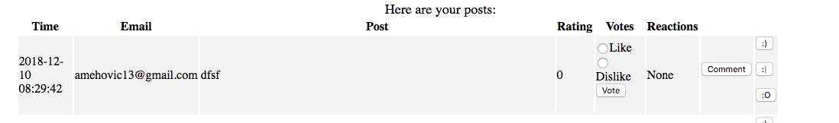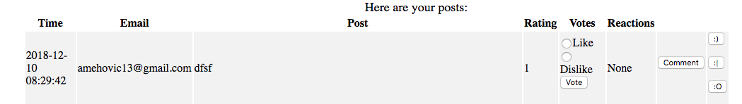

**FEATURE #2 .** Defriend

a. Huy

b. This feature allows users to be removed from a group. This means they will not be able to view posts or be tagged to view content in that group

c. This is a good feature because it allows for control as to who can view content item in groups. Sometimes groups might face conflict and there might be a need to defriend users.

d.

E. if (data):

query2 = "DELETE FROM Member WHERE owner_email = %s AND fg_name = %s AND email_creator = %s"

f.

G.

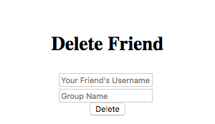

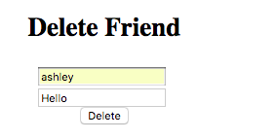

**FEATURE #3 .** Group Tagging

**a. Kyra**

b. This feature allows users to tag on content that is visible to them.

c. This is a good feature because it allows users to share posts with one another

**FEATURE #4 .** User Profile

**a. Ashley and Huy**

b. Users post information about themselves that is visible to other users.

c. This is a good feature because it allows users to maintain credibility. Usually people will follow a group if there are mutual profiles that they recognize. Users are easily recognized with a profile account.

d. CREATE TABLE `contentitem` (

`item_id` int(11) NOT NULL,

`email` varchar(20) DEFAULT NULL,

`post_time` timestamp NULL DEFAULT NULL,

`file_path` varchar(100) DEFAULT NULL,

`item_name` tinytext,

`is_pub` tinyint(1) DEFAULT NULL,

`tot_votes` tinyint(4) DEFAULT '0',

`comment_on_item` int(11) DEFAULT NULL

) ENGINE=MyISAM DEFAULT CHARSET=latin1;

Added the comment_on_item so that there is a comment associated to the post

e. query = 'UPDATE person SET about_me = %s WHERE email = %s;'

f. query = 'UPDATE person SET about_me = %s WHERE email = %s;'

g. 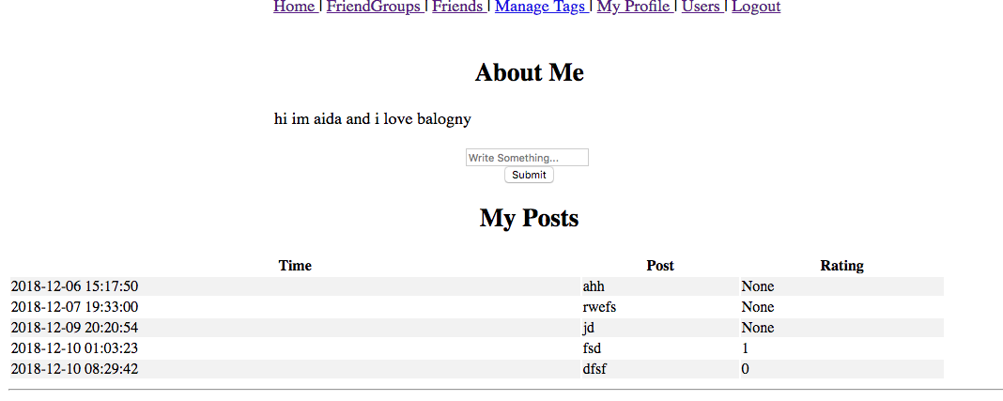

**FEATURE #5 .**Add comments to post

**a. Ashley**

b. This feature allows users to comment on content that is visible to them.

c. This is a good feature because it allows users to communicate with one another on posts and share their thoughts outside of the standard liking and disliking on a post.

d. `comment_on_item` int(11) DEFAULT NULL

Comment item to be associated with a distinct post

e. query = 'INSERT INTO contentitem (item_name, email, post_time, is_pub, comment_on_item)\ VALUES(%s, %s, %s, %s, %s)'

query = 'SELECT post_time, item_name, email, item_id, tot_votes FROM contentitem WHERE comment_on_item = %s'

f. query = 'INSERT INTO contentitem (item_name, email, post_time, is_pub, comment_on_item)\VALUES(%s, %s, %s, %s, %s)'

g.

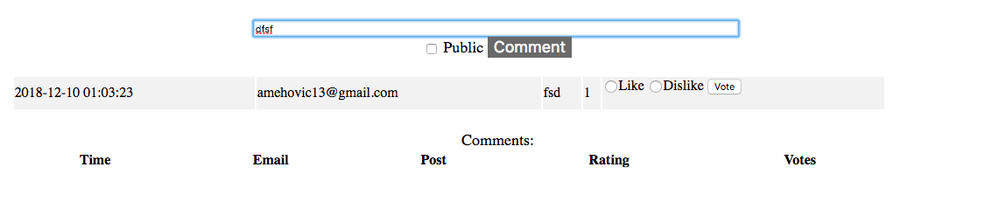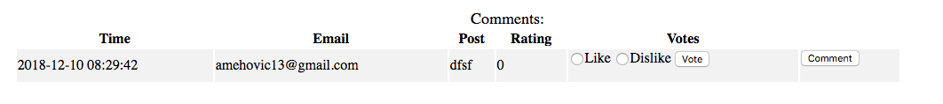

BEFORE :

(21, 'Ash', '2018-12-06 14:45:53', NULL, 'post', 0, 1, NULL),

(22, 'amehovic13@gmail.com', '2018-12-06 20:17:50', NULL, 'ahh', 0, 0, 14),

(23, 'amehovic13@gmail.com', '2018-12-08 00:33:00', NULL, 'rwefs', 0, 0, 22),

AFTER:

(21, 'Ash', '2018-12-06 14:45:53', NULL, 'post', 0, 1, NULL),

(22, 'amehovic13@gmail.com', '2018-12-06 20:17:50', NULL, 'ahh', 0, 0, 14),

(23, 'amehovic13@gmail.com', '2018-12-08 00:33:00', NULL, 'rwefs', 0, 0, 22),

(24, 'amehovic13@gmail.com', '2018-12-10 01:20:54', NULL, 'jd', 0, 0, 23);

**FEATURE #6 .**Add Emoji’s to post

a. Aida

b. This feature allows users to add quick responses to a post by choosing an emoji that best reflects their opinion of the post. There is a choice of 4 emojis; the user can respond with any of the emojis and are not limited to just choosing 1 emoji that reflects their reaction of the post they are viewing.

c. This is a good feature because it allows users to react to content quickly outside of the standard ‘liking’ and ‘disliking’ a post. Users have the choice to react to content quickly in one click rather than writing a wall of text in the comment sections.

e. query = 'INSERT INTO emoji (post_id, emoji,)\

VALUES(%s,%s)'

cursor.execute(query,(item_id, str(emoji)))

f. 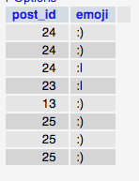

g. 